Supplementary Materials for:

Ultra-efficient Thermo-Acoustic Conversion through a Split Ring Resonator

**Authors**

Lu Lan1, Yueming Li2, Tiffany Yang-Tran1, Ying Jiang1, Yingchun Cao3, and Ji-Xin Cheng1,3,4*

**Affiliations**

1Department of Biomedical Engineering, Boston University, Boston, MA 02215, USA.

2Department of Mechanical Engineering, Boston University, Boston, MA 02215, USA.

3Department of Electrical & Computer Engineering, Boston University, Boston, MA 02215, USA.

4Photonics Center, Boston University, Boston, MA, 02215 USA.

**\***Corresponding author. E-mail: [jxcheng@bu.edu](mailto:jxcheng@bu.edu).

**Resonance effect enhances the conversion efficiency of microwave into ultrasound using graphite rods**

To test our hypothesis of using a resonance antenna to create strong localized electric field for high conversion efficiency of microwave into ultrasound, we first tested graphite rods of 0.7 mm diameter with different lengths: 12.7, 39, 50 and 60 mm (**Fig. S1a, b**). It is known that the electric field concentrates at the tips of a λ/2 dipole antenna. Thus we hypothesized that the graphite rod will function as a λ/2 dipole antenna to produce hotspots at the tips, if its length matches the half wavelength of the microwave excitation. In experiments, with 1 µs excitation pulse at 2.2 GHz, only the 39 mm long graphite rod produced strong acoustic signal, while 12.7 and 60 mm long ones barely generated a detectable ultrasound signal (**Fig. S1c**). In addition, a resonance peak appeared around 2.18 GHz for the 39 mm long graphite rod (**Fig. S1d**) when the excitation frequency was tuned. For the 50 mm long graphite rod, the resonance peak seems to be of lower frequency outside of the limited excitation window we have here. This was also the case for the 12.7 and 60 mm long graphite rod. Thus, the resonance effect indeed boosts up the conversion efficiency of microwave into ultrasound.

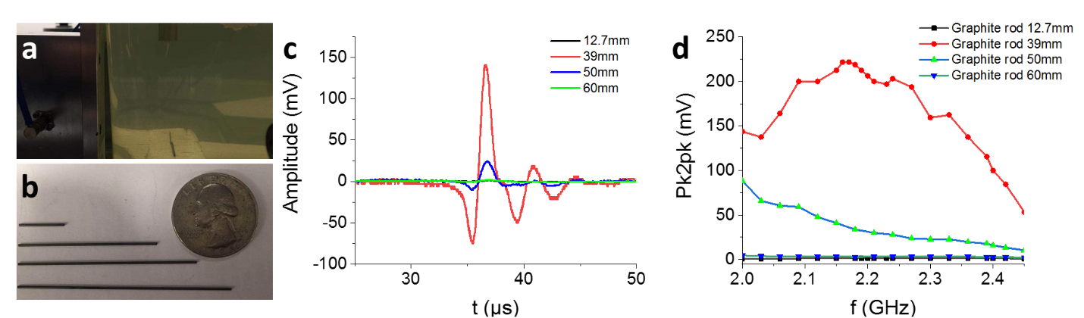

**Figure S1. Resonance effect enhances the conversion efficiency of microwave into ultrasound**. **a** Graphite rod placed in oil tank for acoustic measurement. **b** Photos of graphite rod of 12.7, 39, 50 and 60 mm length used in experiments. **c** Acoustic signal detected from graphite rods. **d** Peak-to-peak (Pk2pk) values of the acoustic signals from graphite rods of different length over different excitation frequencies.

**Gap is important to create resonance on the SRR and generate strong ultrasound wave.**

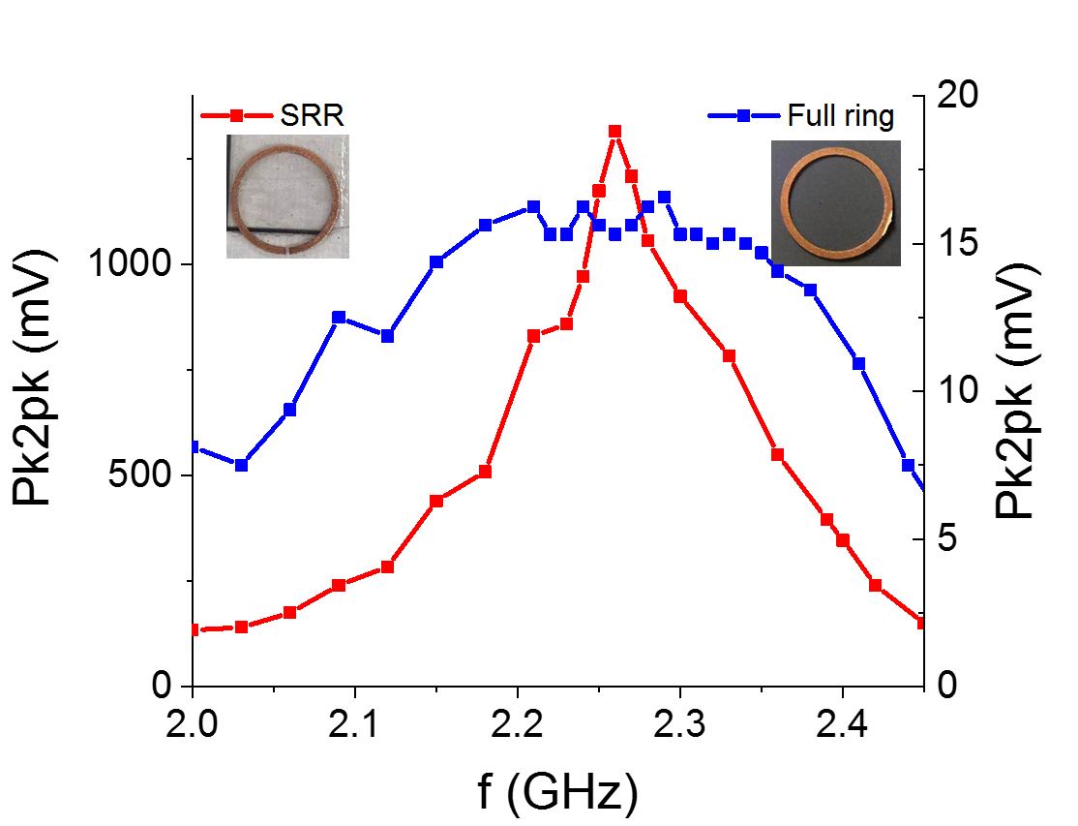

**Figure S2. Comparison of the acoustic signal generation between the SRR and a full copper ring of the same size.** Red line is SRR and blue is full ring.

We also compared the split ring resonator with a full ring of the same size to prove the strong enhancement of acoustic generation by resonance effect. A full ring of the same diameter was placed in the oil and its acoustic signal was measured over different excitation frequencies under the same experimental condition. **Fig. S2** shows the spectra of the SRR and full copper ring in one plot. It is seen that SRR has clear resonance effect around 2.27 GHz, while the full ring presents a wide peak close to the size of the whole excitation window, showing possible weak resonance effect. Also, the strongest peak-to-peak (Pk2pk) value from the full ring reached only 18 mV, while it is1320mV for SRR on resonance, showing two orders improvement. It is understandable that the full ring only has the joule heating effect induced by the friction of free electrons circulating inside the ring following the quick alternating microwave. Therefore, the gap is important to create resonance on the SRR to enable strong acoustic generation.

**Simulation of the SRR placed in the air-oil interface to compare with the thermal imaging experiments**.

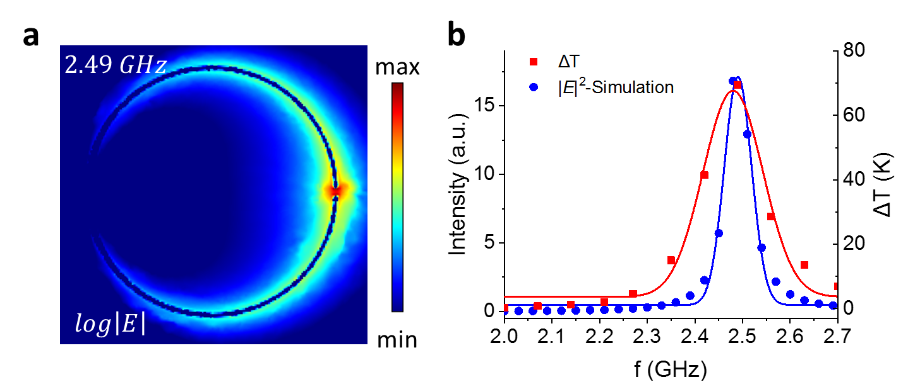

**Figure S3. Simulation and experimental data of SRR in thermal imaging experimental condition. a** Simulated intensity map of electric field in log scale on the SRR when it is on resonance (2.49 GHz), **b** Simulated intensity of electric field in the gap over different excitation frequencies (blue dotted line) and measured temperature rise in the gap of SRR over different excitation frequencies (red squared line).

To experimentally confirm the existence of thermal hotspot generated by the copper SRR in oil, we imaged the SRR shallowly submerged in oil. We mounted the ring on a thin plastic film, flipped the film and made it float on a small oil container. By doing so, the ring was shallowly immersed in oil and the mid-infrared light radiated from the ring can be captured by the thermal camera. To understand how the interface configuration affects the resonance, we first simulated this case with COMSOL Multi-physics. The resonance frequency was found to shift to 2.49 GHz. **Fig. S3a** shows the simulated intensity map of electric field on the SRR in log scale. When plotting the electric field intensity in the gap over microwave frequencies, the resonance peak was around 2.49 GHz with a full-width half-maximum (FWHM) of 0.07 GHz (**Fig. S3b**). In thermal imaging experiments, the temperature rise with 250 ms microwave heating of different frequencies was also obtained and plotted in **Fig. S3b**, which has a peak of 2.48 GHz that is consistent with the simulation. Similarly, the experimental data showed larger FWHM of 0.15 GHz, which is understandable since the absorption for heating effect will broaden the resonance peak as indicated in **Fig. 1**.

**Visualization of thermo-acoustic signals from the SRR at different angles**

To study the acoustic generation profile, we used thermo-acoustic (TA) imaging system to measure the thermo-acoustic signal from the gap at different angles, shown in **Fig. S5a** below. The same ultrasound transducer probe was oriented at different angles to plane using a motorized stage. **Fig. S5b-h** shows the merged ultrasound (green) and thermo-acoustic (red) images at different detection angles, and larger angles beyond 60 degrees were not accessible given the rotation constraints in experiments. In all angles except 20 degrees that the TA signal was detected and confirmed inside the gap of the SRR. This directional emission profile can be reason that the gap width *w* of 0.8 mm and gap thickness *t* of 0.2 mm in comparison to the ~mm wavelength of sub-MHz frequency ultrasound. It is well known that acoustic emitter of size less than 1/3 of acoustic wavelength of emission acts more like point-source emission while directional emission is obtained when the emitter size is comparable to the acoustic wavelength 1. It explains why more directional emission is obtained in a z direction and a dip of acoustic signal at 20 degrees angle, since the gap width is 0.8 mm and comparable to acoustic wavelength. In contrast, the gap thickness is smaller, rendering a more point source like acoustic emission in y direction, consistent with experimental measurements with signals from the 30-60 degree angles.

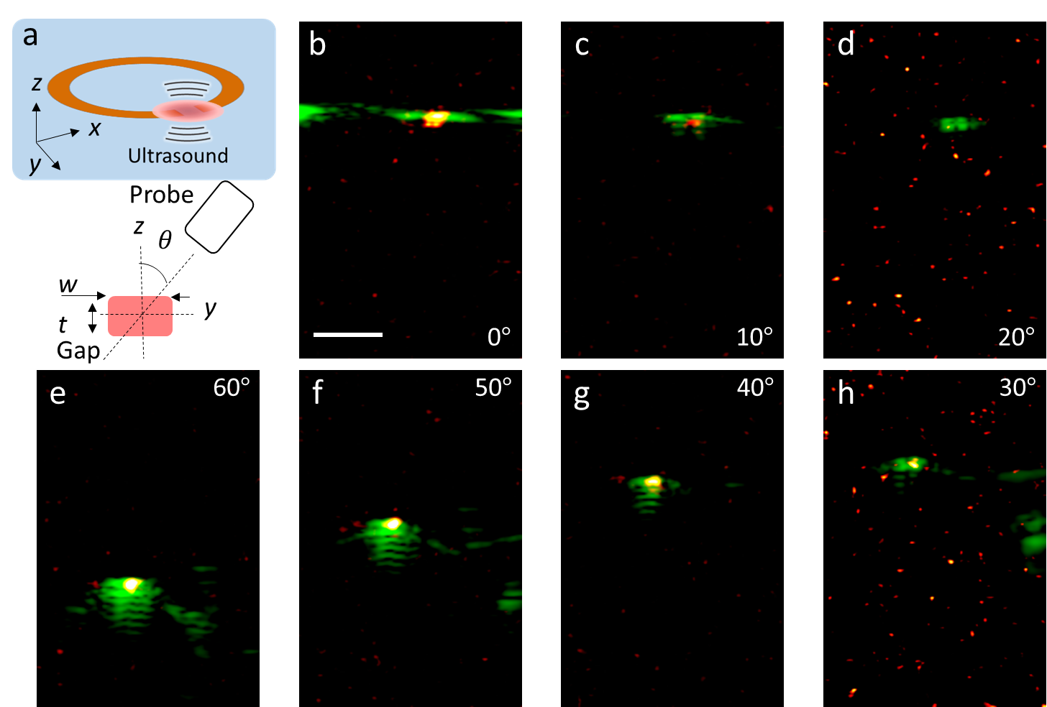

**Figure S4. Detecting the thermo-acoustic signals at different angles to the plane of the SRR using transducer array. a** Schematics of experimental configuration. **b-h** Merged ultrasound (green) and thermo-acoustic (red hot) images at different angles as marked. Scale bar: 5 mm.

**Effect of microwave pulse duration on the thermo-acoustic signal generation**



**Figure S5. Effect of microwave pulse duration on TA signal generation. a, c** Time-of-flight acoustic signals measured with excitation of different pulse durations by a single element transducer of 5 and 0.5 MHz center frequency, respectively. **b, d** Peak-to-peak values of the acoustic signals measured over different microwave excitation pulse durations by a single element transducer of 5 and 0.5 MHz center frequency, respectively.

The excitation pulse duration affects the acoustic signal generation on its amplitude, efficiency, etc. Given the challenges of having a high-energy nanosecond laser source with tunable pulse duration, the effect of pulse duration on acoustic signal generation is not fully investigated (*ref. 33* *in main text*). Since changing the pulse duration of microwave excitation can be done electronically, we measured the acoustic signal generated from the SRR with different pulse durations by two single element transducers with 5 and 0.5 MHz center frequencies under the same experimental conditions. **Fig. S5a, c** shows some representative acoustic waveforms over different pulse durations measured by single element transducers of 5 and 0.5 MHz center frequency, respectively. It is seen that the acoustic signal changes with different pulse durations. Specifically, two bipolar acoustic signals appeared with long pulse durations, such as 2 µs excitation pulse in **Fig. S5a** and 5 µs pulse in **Fig. S5c**. It is a result of two acoustic pulses generated from the rising and falling edges of the excitation pulse and becomes discernible when the excitation pulse duration exceeds the response time of the detectors. We plotted the peak-to-peak values of the acoustic signal over the excitation pulsed duration in **Fig. S5b, d**. It is seen that the pk2pk values first increased with longer pulse durations since more pulse energy was input on the SRR. Then, the pk2pk value started to drop after pulse duration of 0.6 µs for 5 MHz transducer and 1 µs for 0.5 MHz transducer. It agrees well that 0.5 MHz detector has smaller bandwidth than that of 5 MHz and thus needs longer response time to discern the two acoustic signals generated from rising and falling edges of the long excitation pulses.

**Visualize the splitting of the acoustic wave generated from long excitation pulse durations measured by the L7-4 transducer array**.

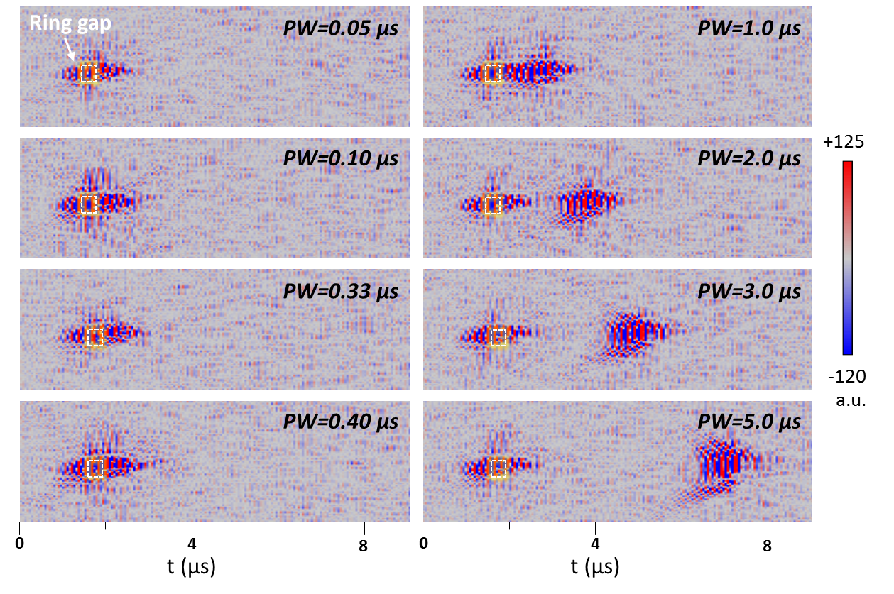

**Figure S6. Radio-frequency data retrieved from TA images acquired by the ultrasound system with different excitation pulse durations.**

To confirm the splitting of acoustic signals generated with long excitation pulse duration that exceeds the response time of the detector, we used our TA imaging system to record the TA images with different excitation pulse durations. **Fig. S6** shows the radio-frequency (RF) data retrieved from the ultrasound system to better present this effect, The RF images were oriented for 90 degrees to present the time axis in horizontal direction. The splitting effect started to appear with pulse duration longer than 0.4 µs, where a tail after the gap started to show up. It became more obvious with even longer pulse duration of 1 µs. Noticeably, the second acoustic wave packets, which correspond to the falling edge of the microwave excitation pulse were slightly larger in intensity than the first one, which suggests an increased Grüneisen parameter for the second acoustic pulse generation by the local thermal residue from the start of the heating pulse.

**Efficiency of TA generation with different excitation pulse durations measured by a single element transducer of 5 and 0.5 MHz center frequency.**

If defining the excitation efficiency to be the peak-to-peak of the acoustic signal over the pulse duration of microwave excitation, we obtained two efficiency curves using the 5 and 0.5 MHz transducer (**Figure S7**). It is found that the excitation efficiency firstly increased to its maximum at certain pulsed duration and subsequently starts to drop when the pulse duration increased from 0.05 to 5µs. The pulse duration for maximum efficiency was found to be around 0.1 µs using both the 5 and 0.5 MHz transducer. This means that the thermo-acoustic signal can be further enhanced if microwave excitation pulse with higher peak power and shorter pulse duration.

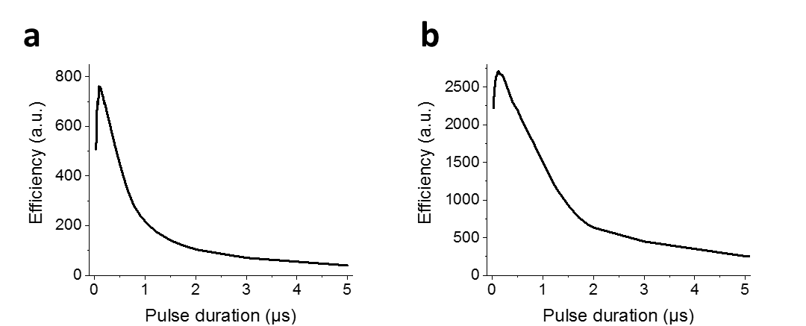

**Figure S7. Efficiency of TA generation with different excitation pulse durations measured by a single element transducer of 5 (a) and 0. 5 (b) MHz center frequency, respectively**.